CropPulse: AI Sentinels against Crop Diseases
Suyash Srivastava¹, Yashna²
School of Engineering and Sciences, GD Goenka University
Gurugram, India
¹avisuyash61@gmail.com
²yashna2527@gmail.com

Abstract
Agriculture is crucial for global economy, particularly in developing countries where the majority populace relies on it as a source of livelihood. One of the greatest challenges farmers are confronted with today is the timely and precise detection of crop diseases, which affect crop yield and quality. Traditional disease identification has relied on manual inspection, which could be laborious, faulty, and largely out of reach for smallholder farmers due to limited resources or unavailability of expert data. In a bid to overcome such a handicap, the current study aims at developing a detection system for crops through image processing in combination with machine learning, that is, the (SVM) classifier. This paper explains a variety of methods, with reference to recent upgrades in machine & deep learning, digital image processing that made disease diagnosis based on leaf texture analysis more precise and reliable. The paper suggests a reliable system allowing early and efficient plant disease diagnosis using quality imaging equipment, sophisticated data analysis, and smart classification algorithms.
Experiments shows that the system can accurately identify a number of plant diseases. The findings demonstrate the potential of using automation to enhance productivity significantly, while also improving sustainability in agriculture. These experimentally demonstrate high accuracy in detecting multiple plant diseases, emphasizing the potential
Index Terms - Artificial intelligence, Disease Detection, Machine learning, SVM, Deep Learning.
INTRODUCTION
India is an agricultural nation where the majority of people work in agriculture. The prospective of agricultural findings is to boost food quality and productivity while lowering costs and increasing profit. The result of a complicated interplay between soil, seed, and agrochemicals is an agricultural production system (Gavhale & Gawande, 2014). A large number of developing nations rely heavily on agriculture. Over 60% of people are employed in this industry. The agricultural sector is vital for food, housing, and clothing, making it a fundamental part of the economy (Annabel et al, 2019). Recent advances in processing images and recognising patterns techniques can help considerably strengthen the autonomy of an autonomous framework for disease field detection. If different pesticides were used to control the illnesses, the agricultural land would be completely devastated.
(Vamsidhar et al, 2019). Thousands of pictures can occasionally be produced in a single biological science experiment. These photos may be needed for additional research, such as categorizing lesions, rating quantitative characteristics, or figuring out how much area insects eat. Nearly all of these tasks are done by hand or with various software programs (Hettiarachch & Wedasingha,2010). Furthermore, farmers employ a time-consuming, expensive, and error-prone broad observation method. To overcome these obstacles, the agriculture sector urgently needs to adopt technology. Technologies such as deep & machine learning, computer vision offer innovative methods of pest identification and control (Singh et al, 2020). Photos categorization is a demanding task of knowledge acquisition that assists medical practitioners in making decisions. Various versions of classification are applied to medical images. They involve texture classification, image processing, in an effort to categorize the different regions of an image depending on their texture feature. The use of neural network-based classification techniques either unsupervised or supervised cannot be overstated and cannot be understated (Gavhale & Gawande, 2014). Deep learning techniques have made it possible to diagnose diseases through images. Machine vision provides an appropriate platform for the detection of pests through the use of image processing technology (Vamsidhar et al, 2019). Digital imaging is itself a fundamental method employed in the quantification, diagnosis, and classification of plant diseases (Barbedo, 2013). Model learning is highly effective when applied for accurate detection of plant diseases (Ferentinos, 2018). Machine learning is used in estimating crop yield and determining nitrogen levels in precision agriculture (Chlingaryan et al, 2018).

LITERARY OVERVIEW
Classification of Images
Image classification is an inexpensive technique applied to translate and analyze visual information economically. In medicine, it helps doctors recognize patterns and abnormalities within diagnostic images to enable proper clinical judgment. The classification method is chosen based primarily on the intended application and field of use. Surface classification is especially essential for its potential to recognize picture zones on the premise of surface attributes—used not only in agriculture but indeed in medicine. (Gavhale & Gawande, 2014).. Another vital strategy is neural arrange classification, which incorporates both administered and unsupervised procedures (Shruthi et al., 2019).
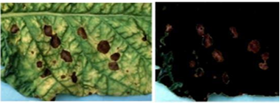
Figure 1: Picture with disease (Vamsidhar et al., 2019)
Support Vector Machine (SVM)
SVM analyses data and computational technique used to evaluate data and define relationships among diverse types of data. It is primarily designed for differentiating between more classes (Hettiarachch & Wedasingha, 2010). The training process in SVM aims to find the best linear hyperplane that minimizes potential errors due to unknown factors. SVM performs well with multi-dimensional, non-discrete features. However, it has limitations such as:

- Longer response times.
- Inability to handle isolated attributes.
- The need for a large sample size to achieve accurate predictions (Annabel et al., 2019).
In image classification using SVM, the process involves comparing the training feature vector with the testing feature vector to determine the target class. The formal representation is:
P={(x,y)∣xi​∈Rn,yi​∈{−1,1}}
Figure 2 (Waldamichael et al., 2022).

OVERVIEW TO IMAGE SEGMENTATION
Image segmentation’s fundamental aspect of computer vision & it’s applications in various fields such as autonomous systems, object recognition, and medical image analysis
A key component of computer vision is image segmentation, which has applications in diverse areas including autonomous systems, object recognition, and medical image examination. This review examines main core types of image segmentation: semantic segmentation, instance segmentation, and panoptic segmentation. Besides, the papers analyse various segmentation methods such as Watershed, Edge, Boundary, Region, Cluster, and Semantic Segmentation (Singh et al, 2020).
INTRODUCTION TO INSTANCE SEGMENTATION
This portion is all about the detection and separation of every occurrence of an object class within a picture. As opposed to the regular object detection system that yields coarse bounding boxes, this method demands pixel-level localization exactly by way of segmentation. Semantic segmentation, which labels all the pixels with category labels, is very variation-rich in output. A semantic segmentation system can't distinguish between instances. It finds and identifies each instance of an object class within an image. Unlike standard object detection that produces rough bounding boxes, instance segmentation provides precise pixel-level localization (Waldamichael et al. 2022).
PANOPTIC SEGMENTATION
The purpose of panoptic segmentation is for predicting a class label and an instance ID. It divides visual things into two groups: "stuff" and "things." The "stuff" group includes uncountable regions like the sky or water with a single instance identifier. In contrast, the "things" group is countable objects like human beings and vehicles that have different instance IDs. The proposed method brings in an end-to-end deep neural network capable of doing real-time panoptic segmentation by combining semantic and instance segmentation for full image understanding. (Annabel et al., 2019).

OTHER SEGMENTATION TECHNIQUES
This portion outlines diversified segmentation techniques:
- Watershed Segmentation: is an effective technique used to distinguish and separate objects that overlap within an image. (Gavhale & Gawande, 2014).
- Edge Segmentation: Detects object parameters using detection of edge techniques (Hettiarachch & Wedasingha, 2010).
- Threshold Segmentation: Portion of an image based on intensive values of pixels (Singh et al., 2020).
- Region Segmentation: Neighbouring pixels holding with same aspects are grouped together (Vamsidhar et al., 2019).
- Cluster Segmentation: Pixels are converted into clusters using clustering algorithms (Shruthi et al., 2019).
MACHINE LEARNING IN CROP DETECTION
Machine learning is a branch of artificial intelligence that prioritizes building systems learning from data, pattern identification, and decisions-making with minimal human interaction (Gavhale & Gawande, 2014). Resulting in improved performance over time as exposed to more data.

TECHNIQUES IN MACHINE LEARNING
- Supervised Learning: Uses labelled data for training, where the algorithm learns the relationship between input and output (Singh et al., 2020).
- Unsupervised Learning: Identifies hidden patterns in unlabeled data without predefined outputs (Shruthi et al., 2019).
- Reinforcement Learning: Learns by trial and error, optimizing activity based on rewards (Annabel et al., 2019).

IMPLEMENTATION OF AUTOMATED LEARNING
Machine learning has a diverse parameter of applications, including:
- Speech Recognition: Identifying and converting spoken language into text.
- Image Analysis: Classifying images, recognizing objects, and detecting features (Waldamichael et al., 2022).
- Predictive Analytics: Making future predictions using historical data.
- Autonomous Vehicles: Enabling self-driving cars to make decisions in real-time (Hettiarachch & Wedasingha, 2010).

MACHINE LEARNING IN AGRICULTURE
The implementation of learning techniques in various areas has been significantly impacted by the last decade's latest work in machine and computer vision learning (Vamsidhar et al., 2019). In the agricultural industry, a substantial amount of work has been done on:
- Plant Disease Identification: It has been implemented to detect plant diseases, including coffee and Enset diseases (Singh et al., 2020).
- Crop Yield Prediction: Algorithms can predict yield on the basis of historical and real-time data (Annabel et al., 2019).
- Quality and Growth Monitoring: Monitoring the growth and quality of crops using image analysis (Shruthi et al., 2019).

IDENTIFICATION OF DISEASE BY MACHINE LEARNING
Plant diseases can be identified by analyzing the plant's leaves, stem, and roots (Waldamichael et al., 2022). Imaging can predict damaged leaves, stems, fruits, flowers, and affected areas on the basis of shape and color (Hettiarachch & Wedasingha, 2010).

CLASSIFICATION DISEASE DETECTION IN PLANTS
- Machine learning classification methods categorize illnesses in plant leaves using two main categories:
- Supervised Classification: Utilizes labeled data, where the system is trained on known examples (Singh et al., 2020).
- Unsupervised Classification: Identifies disease patterns without labeled data, discovering hidden structures in the dataset (Gavhale & Gawande, 2014).
METHODOLOGY
The primary aspect of the review is for development of an enhanced system, rapid and secure leaf disease recognition. This research aims to address existing challenges in crop disease diagnosis by improving the feature recognition capabilities of the system (Hettiarachch & Wedasingha, 2010).
There are five main steps used for the detection of plant leaf diseases. The processing scheme consists of image acquisition through digital camera or web, image pre-processing includes Image Enhancement and image segmentation where the affected and useful area are segmented, feature extraction and classification. Finally, the presence of diseases on the plant leaf will be identified.
1) RGB image acquisition
2) Convert the input image into color space
3) Segment the components
4) Obtain the useful segments
5) Computing the texture features

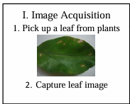
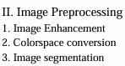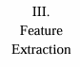
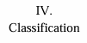
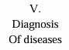
Figure 2: Basic Methodolgy of Image Pre-processing (Hettiarachch & Wedasingha, et al., 2010)

- Data Collection:
  - An objective to gather relevant data.
  - Various studies analyze the obstructions of current image recognition systems (Gavhale & Gawande, 2014).
  - Various datasets and prior research were analyzed (Barbedo, 2016).
- Feature Analysis:
  - The characteristics, issues, and methods of existing image recognition systems were carefully examined.
  - The detailed analysis was conducted to identify the weaknesses in current methods and highlight areas for improvement (Singh et al., 2020).

FEATURE ENHANCEMENT

  - New features were developed and integrated into the recognition system to improve speed and accuracy.
  - Novel techniques of image processing and algorithms of machine learning were implemented (Shruthi et al., 2019)

RESULT EVALUATION:

  - The enhanced machines were tested using various datasets, and the results were decoded and analysed.
  - The findings were then documented in a research paper for publication (Annabel et al., 2019).

TECHNIQUES OF IMAGE PRE-PROCESSING

Region-based
- In this technique pixels that are related to an object are grouped. The area that is detected for segmentation should be closed. Because of missing edge pixels in this region based segmentation there won’t be any gap. The boundaries are identified for segmentation.
Edge-based
- Segmentation can also be achieved by the application of edge detection methods. There are several methods like gradient, log, canny, sobel, laplacian, robert. Here, boundary detection is done in terms of segmentation of the image. Edges are detected to pick out the discontinuities in the image.

Threshold based
- This is the easiest way of segmentation. Here, the segmentation is carried out based on the threshold values calculated from the histogram of both edges of the original image.

Feature-based clustering
- The segmentation process is also done by Clustering. The image is converted to histogram, then clustering is performed on the histogram. Pixels in a color image are clustered in segmentation using Fuzzy C, which is unsupervised. The above technique is used for normal images. (Hettiarachch & Wedasingha, 2010)

Model-based Segmentation
- The segmentation technique using Markov Random Field (MRF) is termed as model based segmentation which is an in-built region smoothness constraint which is utilized in color segmentation combining it with edge detection to locate the edges properly.

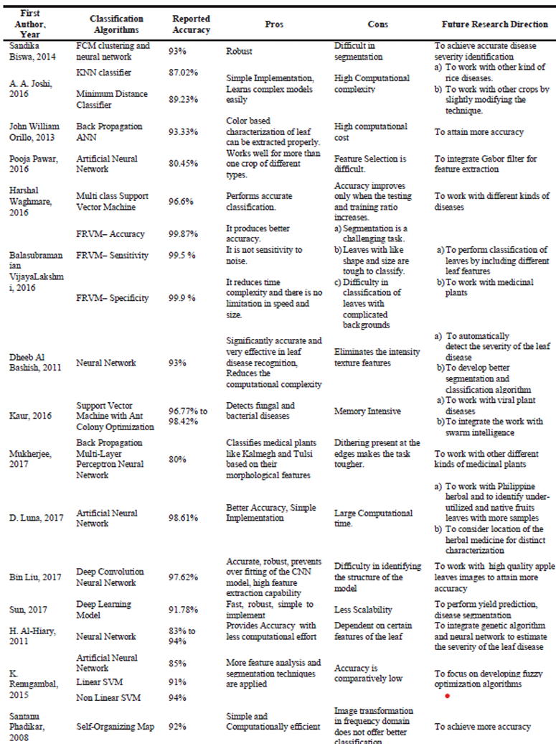

Figure 3: Overall Performance of Classification Algorithms for Crop Disease Detection (Pujari et al., 2016)

RESULTS AND DISCUSSION
Crop Disease Classification
Crop disease classification is a rapidly advancing field, as demonstrated by various findings recognized with remarkable results (Hettiarachch & Wedasingha, 2010). The usage of diverse datasets with unique features has become common, but this also introduces several challenges, including:
- Background Diversity: Different backgrounds can impact accuracy of classification.
- Intraclass Variability: Variations within the same disease category can complicate classification (Gavhale & Gawande, 2014).
- Lighting and Shading Conditions: Changes in light exposure has significant role in quality of a crop image and classification (Singh et al., 2020).
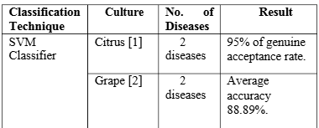
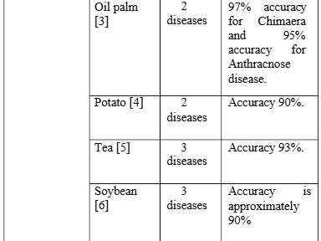
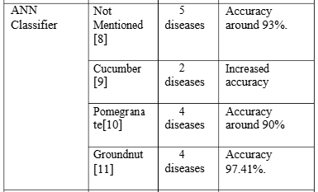
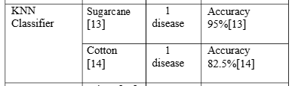
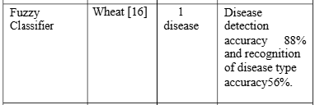
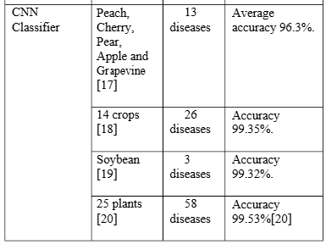
Figure 4: Accuracy & Performance Comparison Table of classifiers (Singh, V., Sharma, N., & Singh, S. 2020)

MANUAL VS AUTOMATED METHOD
Traditionally, plant disease classification relied on manual methods, where experts identified disease forms based on visual inspection. However, these methods are:
- Error-Prone: Due to reliance on human input.
- Time-Consuming: Manually examining a huge amount of images is inefficient.
- Subjective: Results can vary on the basis of observer's experience and past results.

NEED FOR ADVANCE MODEL
To overcome these limitations, advanced automated methods to diagnose crop diseases (Shruthi et al., 2019). These methods offer:
- Improved Accuracy: Algorithms of machine analyze huge datasets for high precision.
- Efficiency: Automated systems have ability to process thousands of images in a short time.
- Consistency: Results are not influenced by human bias.
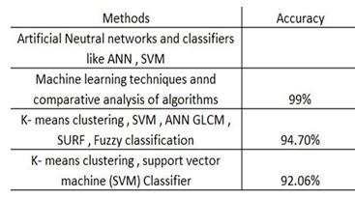
Figure 5: Accuracy level of different models
(Vamsidhar et al., 2019)

FACILITIES REQUIRED FOR PROPOSED

To effectively implement this, we use training machines, several essential resources are required. High-performance computational resources are necessary to manage large datasets and perform complicated imaging tasks, ensuring efficient model training and analysis (Hettiarachch & Wedasingha, 2010). Sophisticated imaging equipment, including high-quality cameras and scanners, is crucial for capturing clear and detailed images of plant leaves, which form the basis of accurate disease diagnosis (Singh et al., 2020). Software tools such as MATLAB, OpenCV, and Python with TensorFlow, Keras, and scikit-learn are indispensable for analysis of image & feature extraction, model construction (Gavhale & Gawande, 2014; Singh et al., 2020; Shruthi et al., 2019). Given the large volume of image data generated, efficient data storage solutions are also necessary, enabling quick access and management of image databases (Annabel et al., 2019). Reliable network connectivity is essential for downloading datasets, collaborating remotely with team members, and accessing cloud-based services, facilitating seamless workflow and data exchange (Vamsidhar et al., 2019). A suitable workspace with proper lighting, environment and atmosphere is vital for capturing high-quality images, minimizing errors caused by poor lighting or shadows (Gavhale & Gawande, 2014). In addition, the expertise of plant pathologists and agricultural specialists is critical for accurately identifying disease symptoms and validating model predictions (Singh et al., 2020). Finally, the collaboration among teammates can be ensured through connected platforms, research management software, and some version control systems, promoting coordinated efforts and streamlined project management (Hettiarachch & Wedasingha, 2010). Together, these resources form the foundation of a reliable and efficient plant disease detection system, enabling accurate diagnosis and early intervention for improved agricultural productivity
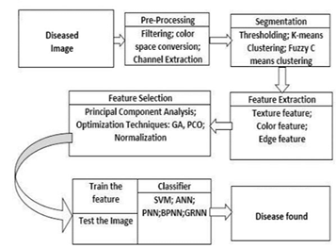
Fig 6: Chart of Disease Diagnosis of Crop (Hettiarachch & Wedasingha, 2010)

REFERENCES
[1] Hettiarachch, M. A., & Wedasingha, N. (2010, March). An Image Recognition System for Crop Disease Identification of Paddy Fields in Sri Lanka. In International Conference on Industrial and Information Systems (ICIIS) (pp. 1-6).
[2] Gavial, K. R., & Gawande, U. (2014). An overview of the research on plant leaves disease detection using image processing techniques. IOSR Journal of Computer Engineering (IOSR-JCE), 16(1), 10-16.
[3] Singh, V., Sharma, N., & Singh, S. (2020). A review of imaging techniques for plant disease detection. Artificial Intelligence in Farming, 4, 229-242.
[4] Shruthi, U., Nagaveni, V., & Raghavendra, B. K. (2019, March). An in-depth inquiry into automated learning systems of classification for disease detection in plants. In 2019 5th International Conference on Advanced Computing & Communication Systems (ICACCS) (pp. 281-284). IEEE.
[5] Annapoorani, L. S. P., Annable, T., & Deepalakshmi, P. (2019, April). Machine learning for plant leaf disease detection and classification–a review. In 2019 International Conference of Communication & Signal Processing (ICCSP) (pp. 0538-0542). IEEE.
[6] Vamsidhar, E., Rani, P. J., & Babu, K. R. (2019). Recognizing and Grouping Plant Pathologies using image processing. International Journal of Engineering and Advanced Technology (IJEAT), 8(3), 442-446.
[7] Pujari, J. D., Yakkundimath, R., & Byadgi, A. S. (2016). Image Processing-Based Screening and Classification of Crop Fungal Infections. Procedia Computer Science, 85, 162-168.
[8] Barbedo, J. G. A. (2013). Efficient Image-Based Plant Disease Recognition and Classification diseases. SpringerPlus, 2(1), 660.
[9] Barbedo, J. G. A. (2016). A review on Data-driven approaches using machine learning for plant disease monitoring and diagnosis, 145, 310-322.
[10] Chlingaryan, A., Sukkarieh, S., & Whelan, B. (2018). Machine learning approaches for crop yield prediction and nitrogen status estimation in precision agriculture: A review. Computers and Electronics in Agriculture, 151, 61-69.
[11] K. P. (2018). Deep learning models for plant disease detection and diagnosis. Computers and Electronics in Agriculture, 145, 311-318.

