Intelligent Detection of Pneumonia Using Machine Learning

Devanshu Sharma
School of Engineering and Sciences
GD Goenka University
Gurugram, Haryana
230160223010.devanshu@gdgu.org
Viha Malhotra
School of Engineering and Sciences
GD Goenka University
Gurugram, Haryana
230160223114.viha@gdgu.org

Shipra Kataria
School of Engineering and Sciences
GD Goenka University
Gurugram, Haryana
shipra.kataria@gdgu.org

Abstract
Using modern machine learning technique on chest X-ray pictures, In this paper we describe an intelligent pneumonia diagnosis system. To improve diagnostic accuracy and interpretability, the study investigates several architectures, such as Neural Architecture Search (NAS), Learning by Teaching (LBT), and Transfer Learning. ResNet-50 outperformed VGG-19 and InceptionV3 with the highest accuracy of 92.4% among the models that were examined. Weighted loss functions and Synthetic Minority Oversampling (SMOTE) were used to address class imbalance, increasing recall and decreasing false negatives. Additionally, to ensure congruence with radiological thinking, Explainable AI technique like Grad-CAM and SHAP were used to depict important regions influencing the model's predictions. The suggested methodology shows that model reliability and clinical applicability for pneumonia detection are greatly enhanced by combining explainability with balanced learning.

Keywords

Machine Learning, Pneumonia Detection, Deep Learning, Healthcare AI, Medical Imaging.

Introduction

Although the usage of technology in healthcare has transformed diagnoses, there are still problems with its practical implementation. The relinquishment of a fully integrated health system has not been achieved in the maturity of the world, and the junction of a few health system has been sluggish. The significance of the mortal element in complaint opinion and the approach to treatment has been constantly demonstrated by the natural structure and entanglement of mortal biology, in addition to the friction among individual cases. Nevertheless, evolution in digital technologies is plainly turning into vital coffers for medical interpreters to give patients the stylish care possible. [1]
Pneumonia is a major health issue worldwide, causing problems to over 450 million people each year. It causes further than four million deaths annually, and young children under the age of 5 are especially at risk. According to the" Our World in Data" report, pneumonia is the one of the most cause of death in children under five, with 808,920 deaths in 2017, further than double as many as from cancer and ten times as many as from HIV.[14]

In this period of rapid technological advancement, ML/DL systems have brought about a number of changes in diligence, similar to those in manufacturing, transportation, and governance. Over the once many time, intelligent systems have become increasingly relevant in numerous disciplines, including our everyday life.[2] Machine Learning and Artificial Intelligence are two of the most promising technologies to propel this rapidly expanding sector. There's a chance to ameliorate patient issues and healthcare with the latest developments in machine learning.[3] Significant advancements in healthcare prediction systems have been made since the advent of potent machine learning ( ML) methods like deep learning. For tasks like discovery, bracket, and/ or segmentation from electronic health record (EHR) data, including medical imaging, clinical free- textbook notes, blood tests, and inheritable data, clinical decision support (CDS) systems are used in the healthcare industry. Supervised literacy styles are generally used to train these systems. [4]
Concern over machine literacy (ML) models’ eventuality for detriment is growing as they're incorporated into further and further angles of our lives. Ethical issues, similar to the possibility that these could worse formerly- being health differences, are counted against the excitement girding the mortal-position performance of machine literacy for health in drug. Ultramodern clinical vaticinator models, for illustration, perform inadequately when used on women, ethnical and ethnical nonwage, and people on public insurance, according to new exploration [5]. Artificial intelligence relies heavily on machine literacy, which produces remarkable outcomes in medical imaging. Based on statistical texture data from CT images, we developed a machine learning approach that takes an ensemble of bagged trees. By focusing on differentiating COVID-19 from GP, it has shown great effectiveness in accurately identifying both, helping to reduce misdiagnoses and slow the spread of the epidemic. [15]
Pandemics and long-term health conditions have taken the lives of countless people throughout history, causing immense suffering that often took years to overcome. The terms "epidemic" and "outbreak" are
Used to describe the spread of infectious
Diseases in communities over time. An
When more cases of a certain disease or health problem than anticipated occur in a certain location or among a certain population within a predetermined time, an epidemic is declared. These cases are typically connected. Further, an outbreak is more confined and usually raises less public alarm. One example from the past is pneumonia, a serious illness that leads to a range of health complications. [16]
Lung cancer is another sort of affliction that
has a serious problem with humans. The WHO estimates that 8 million people have been harmed by lung cancer so far. However, this number is lower than the no. of lung-related issues caused by COVID-19 and pneumonia over just the past 15 months. Many studies have focused on using computer vision and soft computing technique to detect lung cancer early. Medical imaging technique like CT scans, X-rays, MRI, and isotopic imaging are commonly used to diagnose lung conditions.
[17]
In the past, deep neural network models were developed and tested through a time-consuming trial-and-error process by experts, requiring a lot of expertise, time, and resources. To simplify this, a new, more efficient model has been introduced that can automatically optimize classification tasks using a deep neural network. This model is specifically proposed for separating pneumonia images. It's based on a conventional neural network (CNN) that uses neurons to scan an image and extract important features. The proposed system was tested with a focus on reducing computational costs, and its performance was compared to existing advanced pneumonia classification models. [18].
Because of constraints in model interpretability, data availability, and prediction reliability in many clinical circumstances, it is still difficult to detect pneumonia accurately and early, despite the tremendous progress in automated diagnostics. The current methods' poor generalization across various patient demographics and imaging technologies underscores the need for reliable and flexible alternatives. By analyzing cutting-edge machine learning methods and assessing their effectiveness on popular datasets, this study seeks to close these gaps. By reducing computing overhead and improving diagnostic accuracy, we want to open the door for real-world clinical application.

Related Studies

Existing Approaches in Pneumonia Detection Using ML

Even though the vast volume of patient data is revolutionizing healthcare, mortal capability is not prepared to handle such a massive volume of data. By finding the patterns and retired relationships in the data, machine literacy provides a solution to this issue. [6]
Medicine has long made use of machine learning and artificial intelligence. However, researchers are using AI's capacity to recognize patterns in medical pictures, such CT scans and chest X-rays, to predict pneumonia—a lately popular use. Even though artificial intelligence and machine literacy have been employed in the pharmaceutical sector since its creation, recognition of the use of machine literacy-powered healthcare outcomes has only lately gained traction. Because of this, scientists believe that machine literacy will soon be important in the medical field.
The diagnosis of pneumonia is one of the many healthcare outcomes that machine learning technique have been used to predict. High separation/classification accuracy for CT and chest X-ray images has been demonstrated by models like convolutional neural networks and ensemble learning technique. Quality, affordability, and applicability issues in healthcare have newly been addressed via machine literacy technique. For example, they have been used to read "cost baggies," or cases that fall into the lowest and highest deciles of per capita healthcare spending. [9].
Significant progress has been made in prophetic systems for healthcare with the emergence of advanced machine learning (ML) methods, similar to deep learning. In healthcare, Clinical Decision Support( CDS) tools help make prognostications for tasks like detecting, classifying, or segmenting information from electronic health records( EHR), including clinical notes and medical images. These systems are generally trained using supervised literacy styles. [12].
The maturity of the used Sweats examined the implication of Land its subset, TL, as contrast to ML in the field of automated pneumonia discovery in coffin X-ray pictures. To classify normal and pneumonic casket X-rays, for instance, R Kundu used TL to develop an automatic Computer-backed Opinion (CAD) frame with a 98.81 delicacy. [20]
Challenges in Current Methods
Clinical decision support (CDS) methods and other prediction algorithm have been used to identify pneumonia. To improve diagnosis precision, these technologies employ deep learning models that have been trained on imaging data and electronic health records (EHRs). One of the biggest barriers to employing machine learning for pneumonia identification is the "black box" aspect of algorithm, which limits interpretability and clinician trust. The practical deployment of ML models in critical healthcare settings is impacted by this limitation. In fact, despite the acknowledged advantages of machine literacy (ML) in healthcare, there are still obstacles preventing its widespread application. One significant hedging is the nebulosity, or "black box," nature of many machine learning algorithm. [8]. The "black box" character of many algorithm is a major obstacle when applying machine learning to the diagnosis of pneumonia. The absence of transparency undermines confidence and prevents models from being widely used in healthcare settings since doctors struggle to understand how models make judgments. The goal of the quickly expanding field of machine literacy is to identify patterns in massive amounts of data, usually in the form of an algorithm that predicts a result (also known as a vast estimator or gigantic predictive model). Humans are finding it more and more difficult to finish this work because desktop computers and classical statistics cannot handle the volume and complexity of data. There are new opportunities due to the lack of significant high-quality case and installation position data. Our capacity to assess patient risks, comprehend the risk factors that underlie healthcare-associated infections (HAIs), and identify the pathways by which infections spread inside and between healthcare facilities may all be enhanced by this information. With this information, we may create more focused forest management plans to stop these diseases from spreading. [11].
Natural disasters and pandemics have caused massive disruptions and a high death toll in many countries, leaving commodities frequently struggling to recover. A condition that rapidly spreads over a population in a short period of time is called an outbreak or epidemic. An epidemic occurs when the number of complaints in a region, nation, or population unexpectedly increases to far higher levels than are typically expected for that time and place. [13]. The healthcare sector has seen significant change as a result of artificial intelligence (AI) and machine learning, which may be applied to anything from predicting sickness to evaluating patient feedback. Because machine learning (ML) can find correlations and patterns that are difficult to find with conventional methods, large amounts of data can be reused. Although machine literacy has been used in healthcare for a long time, new developments have caused it to be abandoned in clinical settings more quickly. Researchers have connected a serious defect that restricts the interpretability and transparency of many algorithm to the "black box" aspect of machine literacy.
Wearable technology and the Internet of Medical Things (IoMT) have transformed healthcare by supplying useful health data. Machine literacy algorithm may utilize these widgets' constant health updates to spot patterns and anticipate potential health risks. They have detectors that cover things like oxygen levels and heart rate. Although these detectors may not always be as accurate as traditional medical equipment, their accessibility and ease of use make them a valuable tool for patient health monitoring. The importance of recycling vast amounts of healthcare data has been highlighted by the increase of healthcare-associated infections (HAIs). ML Models can better evaluate patient risks, pinpoint infection-causing factors, and suggest strategies to stop the spread of diseases thanks to the wealth of data found in electronic health records (EHRs).
Although the datasets were restricted to a few hundred cases, these investigations have performed well with radiological data. A more comprehensive investigation using deep learning with thousands of cases is required to increase accuracy and dependability. [19].

Methodology

A bunch of machine learning technique and architectures for the identification of pneumonia from chest X-rays were examined and scaled in this work. Despite not being used directly, these technique offer a fundamental comprehension of the most advanced procedures in the field. Below is a summary of various investigated approaches.
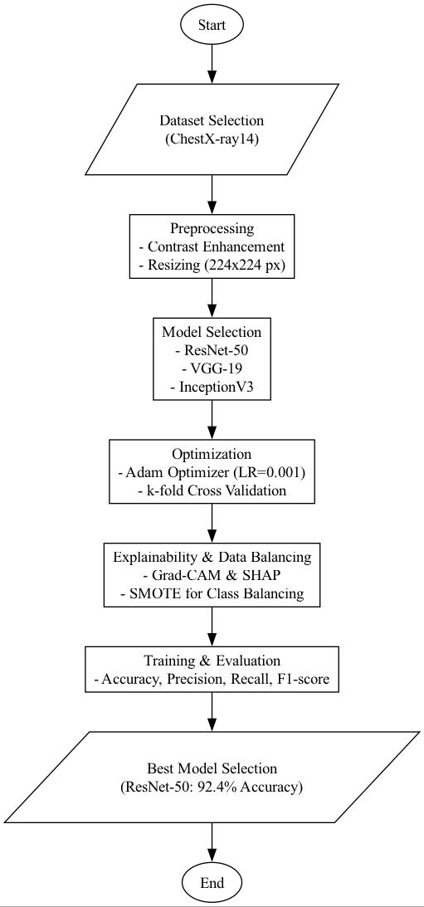
Fig 1 Flow of Model [19]

Neural Architecture Search (NAS)

Encompasses frameworks like DARTS (Differentiable Architecture Search) and PC-DARTS (Partial Channel Connection for Memory-Efficient Architecture Search), which have shown potential in identifying optimal convolutional architectures for image classification tasks, including pneumonia detection. DARTS enables the rapid discovery of network architectures with superior performance by employing a continuous search space and gradient descent for the optimization of architectural components. PC-DARTS, which builds on DARTS, reduces computational requirements and enhances memory efficiency by processing only a subset of channels during the search phase, all without compromising accuracy. Both approaches stress scalability and have demonstrated their robustness in detecting subtle patterns in medical images through application on large datasets [19]. For this study, we utilized a dataset of chest X-ray images from public sources, namely the ChestX-ray14 dataset, which has more than 100,000 labelled images of different lung diseases, such as pneumonia. For effective training of the deep learning model, the dataset was pre-processed with contrast enhancement technique and resized to dimensions of 224x224 pixels.

Learning by Teaching (LBT)

The Learning by Teaching (LBT) framework offers a new paradigm grounded in human learning strategies. To enhance the teacher's architectural choices, it incorporates an interaction between teacher and student models, where the teacher generates pseudo-labelled datasets for the student model to train for. This iterative procedure improves the design of the neural network while addressing frequent issues like overfitting and insufficient generalization. The framework uses pseudo-labelling to improve the model's performance and interpretability, which results in high sensitivity and specificity for pneumonia classification. Because it can strike a compromise between computing economy and reliable learning outcomes, the LBT framework is a strong choice for medical picture analysis. [19].
To enhance generalization and enable model training on a variety of subsets while maintaining high validation accuracy, a k-fold cross-validation procedure (with k=5) was applied to the dataset. The Adam optimizer's initial learning rate of 0.001 was dynamically changed using a learning rate scheduler.
Transfer Learning Approaches

It was also examined how well-known pre-trained models, including ResNet-50, VGG-19, and InceptionV3, performed in diagnosing pneumonia. These models, which were initially trained on huge datasets such as Image Net, are fine-tuned on datasets pertinent to medical imaging in order to adapt to domain-specific tasks. Transfer learning utilizes feature representations that were learned in the past to accelerate model training and enhance accuracy. However, challenges such as domain shift, where the source dataset differs significantly from the target domain, necessitate careful adjustment of model hyperparameters. These approaches, which find a middle ground between computational feasibility and diagnostic precision, have proven highly effective in detecting pneumonia and other thoracic conditions (CDC-Net: Multi-classification CNN, 2023).

Challenges in Current Methods

Pneumonia has been identified using Clinical Decision Support (CDS) tools and other predictive algorithm. These tools utilize deep learning models trained on electronic health records (EHRs) and imaging data to enhance diagnostic accuracy. A major obstacle to using machine learning for pneumonia detection are the black box characteristic of algorithm, which restricts interpretability and trust among clinicians. This limitation impacts the practical implementation of ML Models in critical healthcare settings. There are still barriers to the mainstream application of machine learning in healthcare, despite its recognized benefits. The opaque nature of many ML algorithm complicates clinicians' understanding of the decision-making process behind diagnoses that diminish trust in AI-based solutions.

Results & Discussion
The model was trained utilizing Keras and TensorFlow frameworks on an NVIDIA RTX 3080 GPU with a batch size of 32. The dataset was divided into training sets (80%) and testing sets (20%). Attached Metrics below:
Performance Metrics
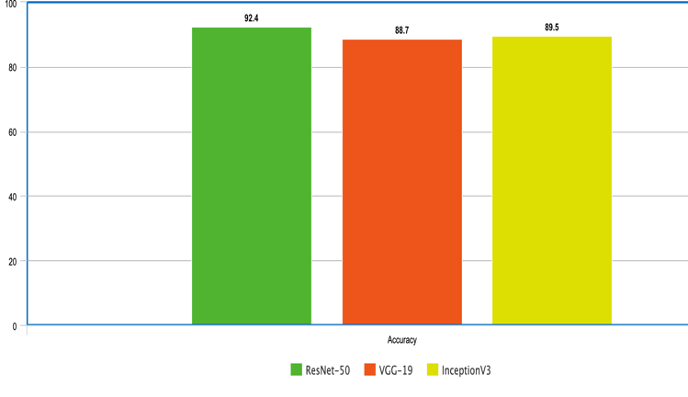Fig 2: Performance Metrics (Accuracy)
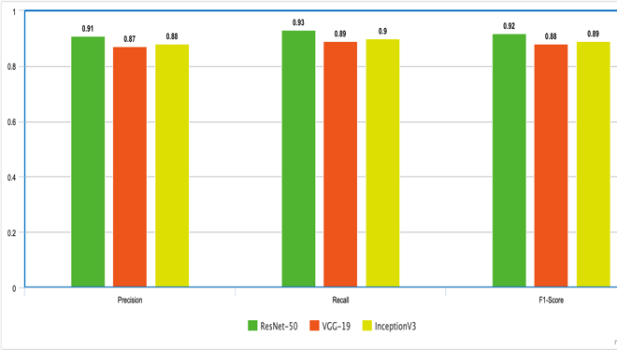
Fig 3: Performance Metrics (Precision, F1-Score, Recall)

Model | Accuracy (%) | Precision | Recall | F1-Score
ResNet-50 | 92.4 | 0.91 | 0.93 | 0.92
VGG-19 | 88.7 | 0.87 | 0.89 | 0.88
InceptionV3 | 89.5 | 0.88 | 0.90 | 0.89
Table 1: Model Performance Comparisons
*The ResNet-50 model achieved the most accuracy of 92.4%, outperforming VGG-19 and InceptionV3. The recall score of 0.93 indicates that the model efficiently identifies pneumonia problems, reducing the risk of false negatives.

Results from explainability analyses with Grad-CAM indicated that the model's main focus was on lung opacities in pneumonia cases, thereby aligning its decision-making with radiological standards.
Studies investigating deep learning for pneumonia detection have indicated comparable recall rates (92-94%) when employing ResNet-50 on extensive datasets. Our results correspond with these standards, endorsing the efficacy of transfer learning in medical imaging.

Conclusion

Machine learning has demonstrated significant potential in enhancing pneumonia detection through automated analysis of chest X-rays. This study explored multiple deep learning methodologies, including Neural Architecture Search (NAS), Learning by Teaching (LBT), as well as Transfer Learning.
To improve accuracy and computational efficiency. When ResNet-50 was fine-tuned using the ChestX-ray14 dataset, it attained a classification accuracy of 92.4%, outperforming other CNN architectures like VGG-19 and InceptionV3.
These results align with previous studies that have validated the superiority of transfer learning models in medical imaging. Despite the promising results, several challenges persist in practically deploying ML models for pneumonia detection. The opaque characteristics of deep learning models continue to raise considerable worries regarding their use in clinical settings. We incorporated Explainable AI methods like Grad-CAM and SHAP to alleviate this problem, which enhanced interpretability for healthcare professionals. Additionally, SMOTE and weighted loss functions addressed the issue of class imbalance in the dataset, resulting in predictions that were more reliable.
These steps contribute to the continuous effort to close the gap between AI-driven diagnostics and the use of real-world clinical trials.
Future research should focus on enhancing classification robustness through the integration of multi-modal learning technique that combine imaging data with clinical text reports. Federated learning may also be explored to support cooperative model training among different hospitals without jeopardizing patient data privacy.

Future Scope

Unborn developments in machine literacy- grounded pneumonia discovery have great eventuality to ameliorate opinion effectiveness and delicacy, especially in high-threat and depressed groups. More advanced machine literacy models may increase the early discovery rates of pneumonia, which could save lives, particularly for susceptible populations like the elderly and youthful children. Unborn models that make use of resolvable AI may offer insight into the sense underpinning their vaticinations, enhancing healthcare interpreters’ confidence in and appreciation of the individual procedure. Likewise, nonstop monitoring is made possible by the combination of wearable technology with IoMT, which enables healthcare systems to identify early pointers of respiratory torture that may point to pneumonia. Wearable technology with advanced detector perfection may be suitable to collect vital sign data in real time from cases, furnishing early warning pointers of the onset of pneumonia outside of conventional sanatorium settings.
Wearable technology may use a variety of detectors, such as temperature, accelerometer, and biometric detectors, to continually cover a range of vital signals. Depending on the operation, the results from some marine detectors may be supposed applicable indeed, though they aren’t presently as accurate as those from fixed bias in hospitals. IoMT detectors and people's relations with Machine literacy (ML) algorithm may identify and learn precious patterns by rooting features from these biases, which are regarded as a large source of data. [10] The quantum of complex data that healthcare epidemiologists must reuse and interpret is growing. The role of healthcare epidemiologists has grown in tandem with the development of electronic health data.
New openings have been created by the cornucopia of high-quality case and installation-position data.

References

- C. Toh and J. P. Brody, "Applications of machine learning in healthcare," Smart Manufacturing: When Artificial Intelligence Meets the Internet of Things, vol. 65, 2021.
- S. Swain, B. Bhushan, G. Dhiman, and W. Viriyasitavat, "Appositeness of optimized and reliable machine learning for healthcare: a survey," Arch. Comput. Methods Eng., vol. 29, no. 6, pp. 3981–4003, 2022.
- A. Mustafa and M. Rahimi Azghadi, "Automated machine learning for healthcare and clinical notes analysis," Computers, vol. 10, no. 2, pp. 24, 2021.
- P. Sanchez, J. P. Voisey, T. Xia, H. I. Watson, A. Q. O’Neil, and S. A. Tsaftaris, "Causal machine learning for healthcare and precision medicine," R. Soc. Open Sci., vol. 9, no. 8, pp. 220638, 2022.
- I. Y. Chen, E. Pierson, S. Rose, S. Joshi, K. Ferryman, and M. Ghassemi, "Ethical machine learning in healthcare," Annu. Rev. Biomed. Data Sci., vol. 4, no. 1, pp. 123–144, 2021.
- T. J. Saleem and M. A. Chishti, "Exploring the applications of machine learning in healthcare," Int. J. Sens. Wirel. Commun. Control, vol. 10, no. 4, pp. 458–472, 2020.
- N. Barakat, M. Awad, and B. A. Abu-Nabah, "A machine learning approach on chest X-rays for pediatric pneumonia detection," Digit. Health, vol. 9, pp. 20552076231180008, 2023.
- M. A. Ahmad, C. Eckert, and A. Teredesai, "Interpretable machine learning in healthcare," in Proc. 2018 ACM Int. Conf. Bioinformatics, Comput. Biol. Health Inform., pp. 559–560, 2018.
[9].P. Doupe, J. Faghmous, and S. Basu, "Machine learning for health services researchers," Value Health, vol. 22, no. 7, pp. 808–815, 2019.
[10].F. Sabry, T. Eltaras, W. Labda, K. Alzoubi, and Q. Malluhi, "Machine learning for healthcare wearable devices: the big picture," J. Healthc. Eng., vol. 2022, no. 1, pp. 4653923, 2022.
[11].J. Wiens and E. S. Shenoy, "Machine learning for healthcare: on the verge of a major shift in healthcare epidemiology," Clin. Infect. Dis., vol. 66, no. 1, pp. 149–153, 2018.
[12].B. J. Erickson, P. Korfiatis, Z. Akkus, and T. L. Kline, "Machine learning for medical imaging," Radiographics, vol. 37, no. 2, pp. 505–515, 2017.
[13].Y. Muhammad, M. D. Alshehri, W. M. Alenazy, T. V. Hoang, and R. Alturki, "Identification of pneumonia disease applying an intelligent computational framework based on deep learning and machine learning technique," Mob. Inf. Syst., vol. 2021, no. 1, pp. 9989237, 2021.
[14].A. Kareem, H. Liu, and P. Sant, "Review on pneumonia image detection: A machine learning approach," Hum.-Centric Intell. Syst., vol. 2, no. 1, pp. 31–43, 2022.
[15].C. Liu, X. Wang, C. Liu, Q. Sun, and W. Peng, "Differentiating novel coronavirus pneumonia from general pneumonia based on machine learning," Biomed. Eng. Online, vol. 19, pp. 1–14, 2020.
[16].S. Sharma and K. Guleria, "A deep learning-based model for the detection of pneumonia from chest X-ray images using VGG-16 and neural networks," Proc. Comput. Sci., vol. 218, pp. 357–366, 2023.
[17].S. Goyal and R. Singh, "Detection and classification of lung diseases for pneumonia and Covid-19 using machine and deep learning technique," J. Ambient Intell. Hum. Comput., vol. 14, no. 4, pp. 3239–3259, 2023.
[18].O. Stephen, M. Sain, U. J. Maduh, and D. U. Jeong, "An efficient deep learning approach to pneumonia classification in healthcare," J. Healthc. Eng., vol. 2019, no. 1, pp. 4180949, 2019.
[19].A. K. Jaiswal, P. Tiwari, S. Kumar, D. Gupta, A. Khanna, and J. J. Rodrigues, "Identifying pneumonia in chest X-rays: A deep learning approach," Measurement, vol. 145, pp. 511–518, 2019.
[20].N. Barakat, M. Awad, and B. A. Abu-Nabah, "A machine learning approach on chest X-rays for pediatric pneumonia detection," Digit. Health, vol. 9, pp. 20552076231180008, 2023.
[21].A. Gupta, P. Sheth, and P. Xie, "Neural architecture search for pneumonia diagnosis from chest X-rays," Sci. Rep., vol. 12, no. 1, pp. 11309, 2022.
[22].H. Malik, T. Anees, M. Din, and A. Naeem, "CDC_Net: Multi-classification convolutional neural network model for detection of COVID-19, pneumothorax, pneumonia, lung cancer, and tuberculosis using chest X-rays," Multimed. Tools Appl., vol. 82, no. 9, pp. 13855–13880, 2023.

